**I-Explore Pre School**

We have a passion for excellence and innovation in preschool education. At the I-Explore Pre School,have over 15 years ofcollective experiencesince 2010 in establishing nurseries tailored to the individual needs, talents, abilities and interests of each child.Preschools build a strong educational foundation for your children. So, choosing the first playschool for your little one is a responsibility to be taken seriously. Every parent looks for a playschool that is safe, easily accessible, and provides a supportive and encouraging environment for their child’s growth. The metropolitan city of Hyderabad boasts an array of playschools with varied facilities, curriculum, and teaching approaches. To make things easier for you, I-Explore pre school compiled as best preschools  in Hyderabad/Secunderabad that nurture your kid’s curiosity and help them establish a staunch base for their future .Language And Literacy Development :Our  unique curriculum is designed with the objective to make children addicted to learning! The methodology ensures that learning is thought provoking and empowering since it is based on the latest theories, brain research and best practices in education.

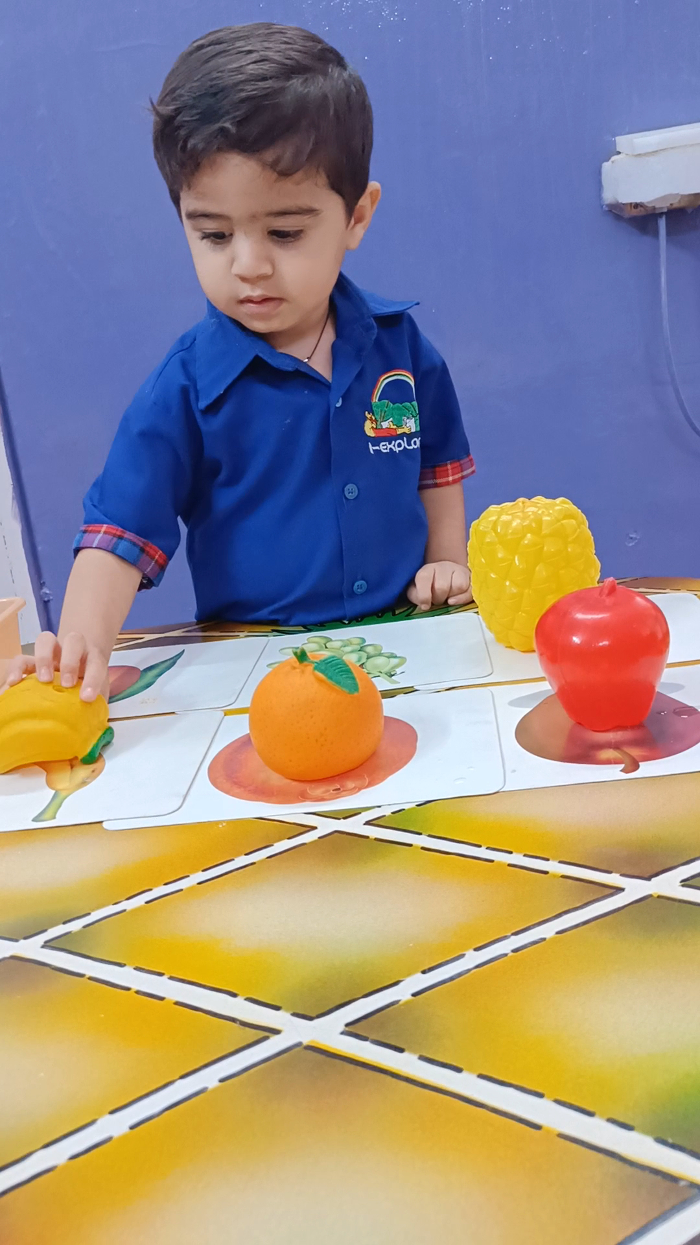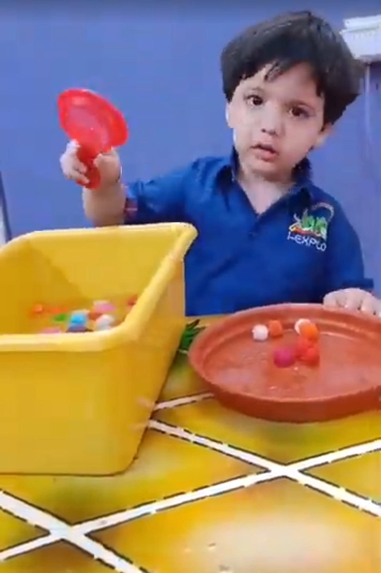

Cognitive Development:Cognitive activities for our tiny ones are tasks and games designed to enhance their mental processes. These activities are not just about learning facts or figures; they're about encouraging kids to think critically, solve problems and understand complex concepts relative to their age groups.

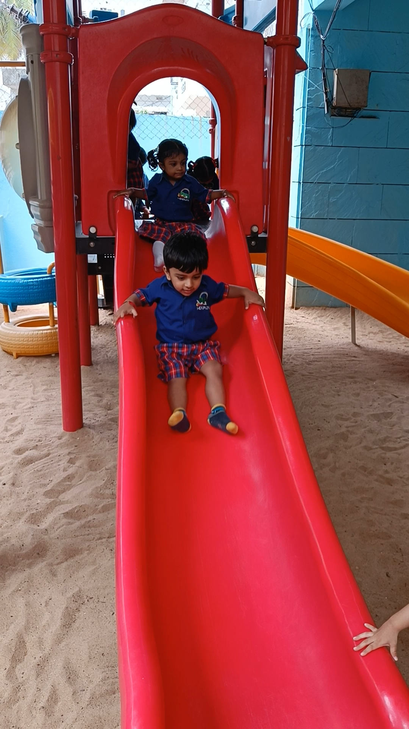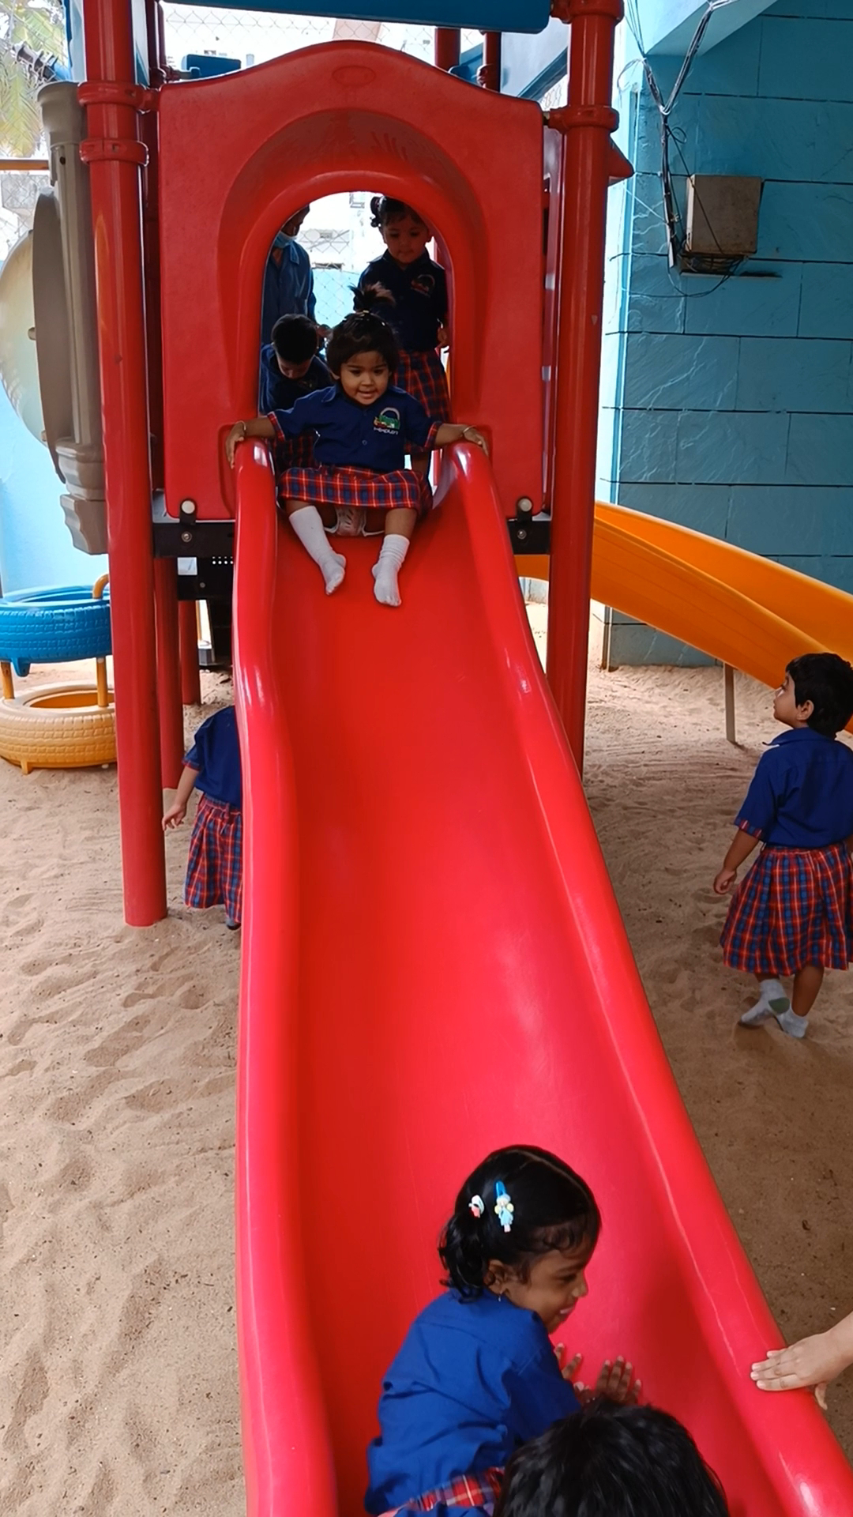

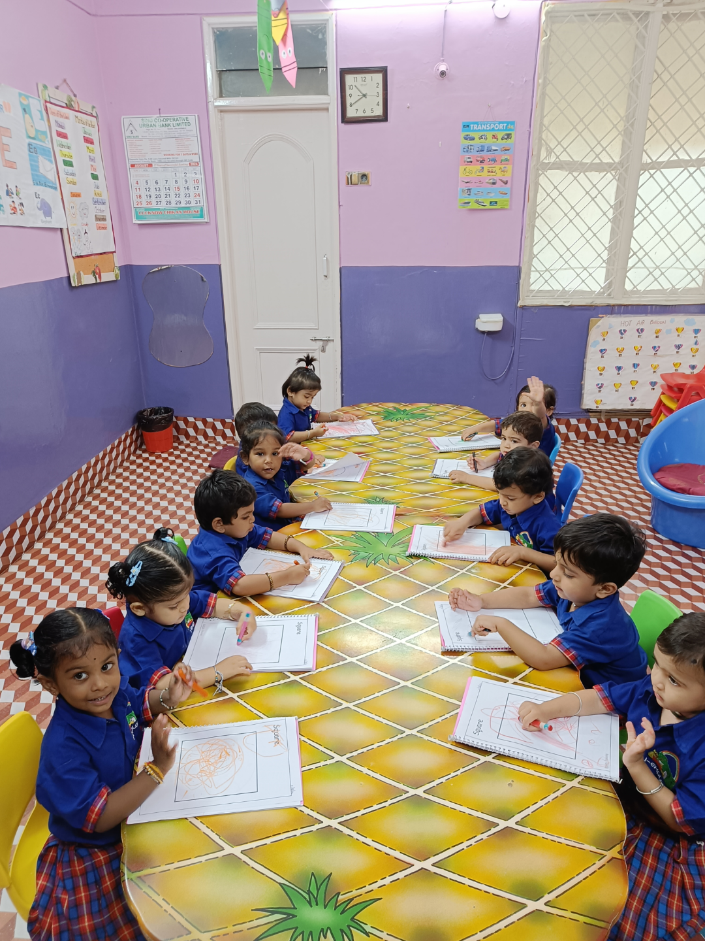

Creative/Aesthetic Development:.Discovery activities, e.g. smelling flowers, grass or spices; observing beautiful fish..Exposure activities, e.g. watching a performance; looking at the detail in paintings..Evaluation activities, e.g. choosing their favourite song/Rhymes.

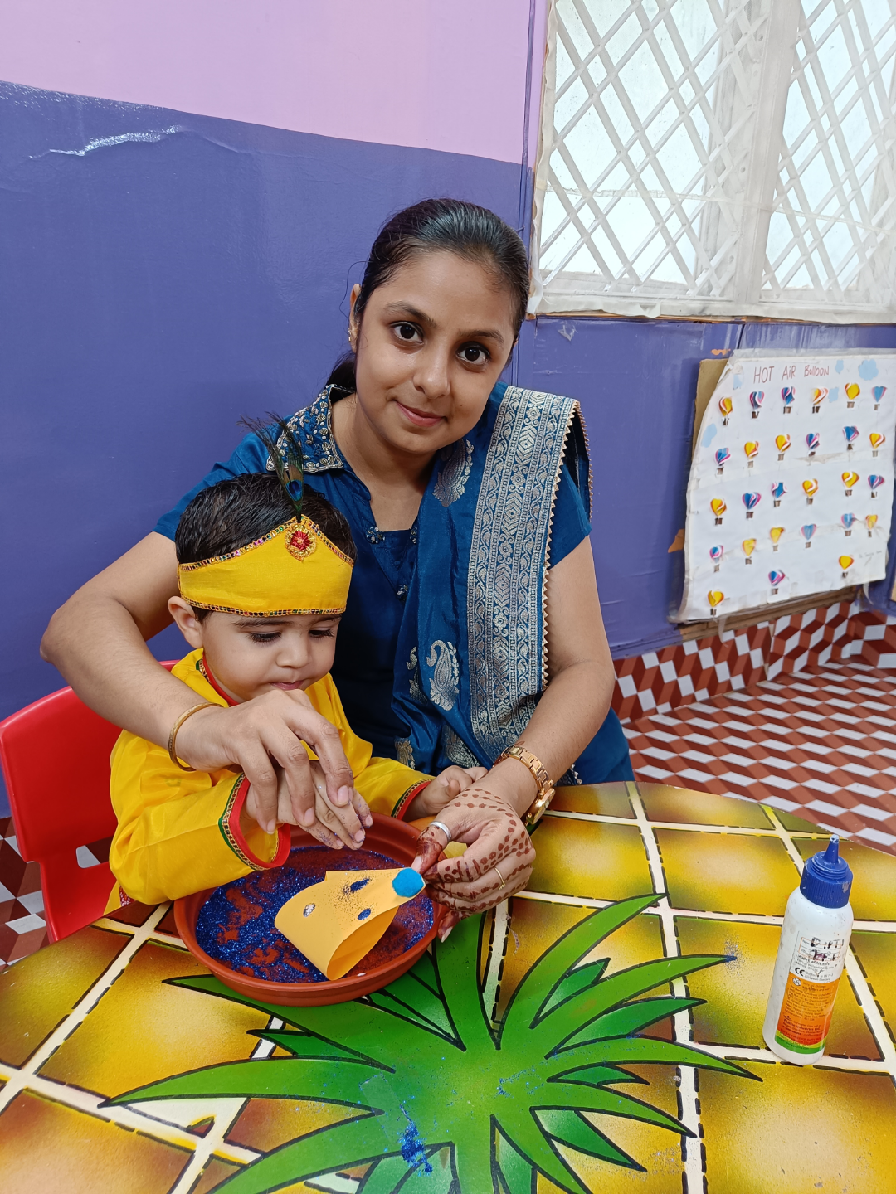

Physical Development:The most effective way to do this is to plan around the basic physical skills – for example, jumping, crawling, bending, galloping, skipping and catching. Children also need to learn social skills such as taking turns, working in pairs and following rules.

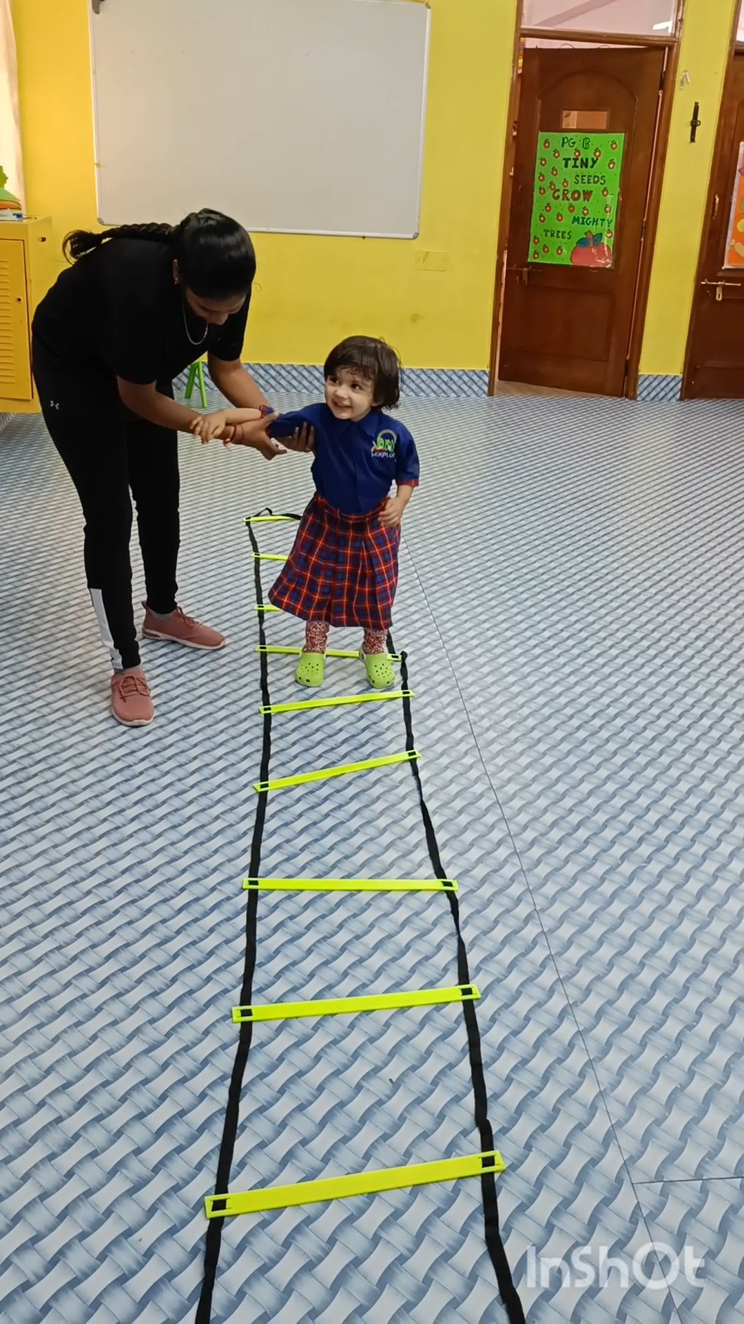

Teaching Testimonials:👉I Ms Pooja Harjani started my journey as ateacher at a very young age.Having these 👇qualities in me: 👉T- Tallented👉E- Encouraging 👉A- Amazing 👉C- Creative 👉H- Helpful👉E- Efficient👉R- Resources full Made me choose my career.👉I am very much passionate about teaching and i turned my passion into profession.👉I joined I-Explore in the year 2018.Ever since I joined I-Explore pre school I have personally explored a lot in  the  teaching field and gained a lot of knowledge by attending several training sessions.

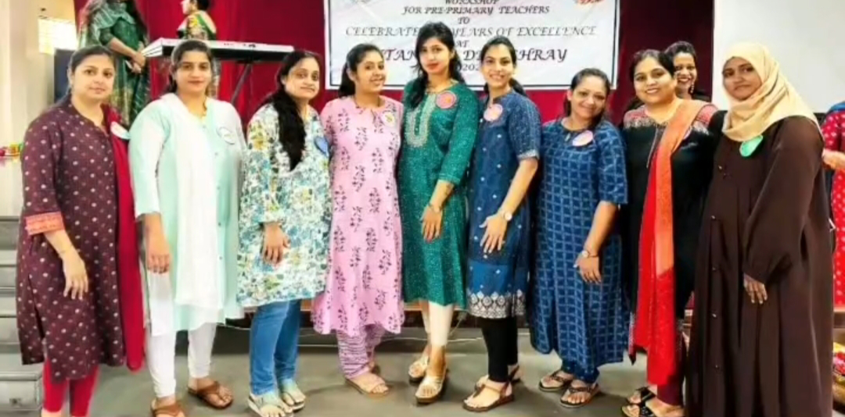

👉As the  school name itself says it all # I-Explore.👉Being a teacher for the tiny ones is not an easy task but working with  Sheetal ma'am made it easy for me. Her support, encouragement, guidance, her trust in me that i can do, is the biggest motivation & cherry on the cake is her smile for me to be so patient, enthusiastic, passionate,creative, punctual towards my job.I- Explore is the next home for me I have made  many memories & experience working with such wonderful  colleagues be it any celebrations with children or events like  christmas carnival, I-Explore Diwali mela, teachers day celebrations,sports day, teachers trainings, becoming Santa🎅,summer camp,dancing with teachers, team lunch & outings.👉The Most memorable & overwhelmed moments for me are children addressing me as #Pooji ma'am#Puju ma'am #Bua #Chachi #Didi #Mummy.

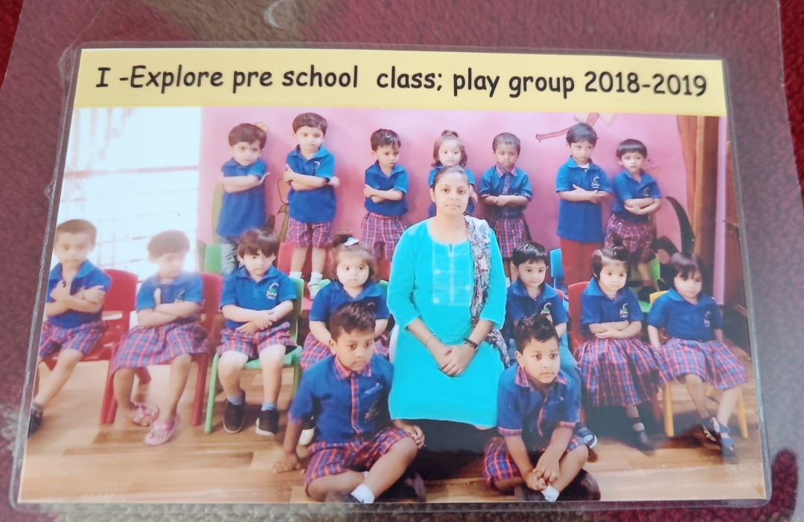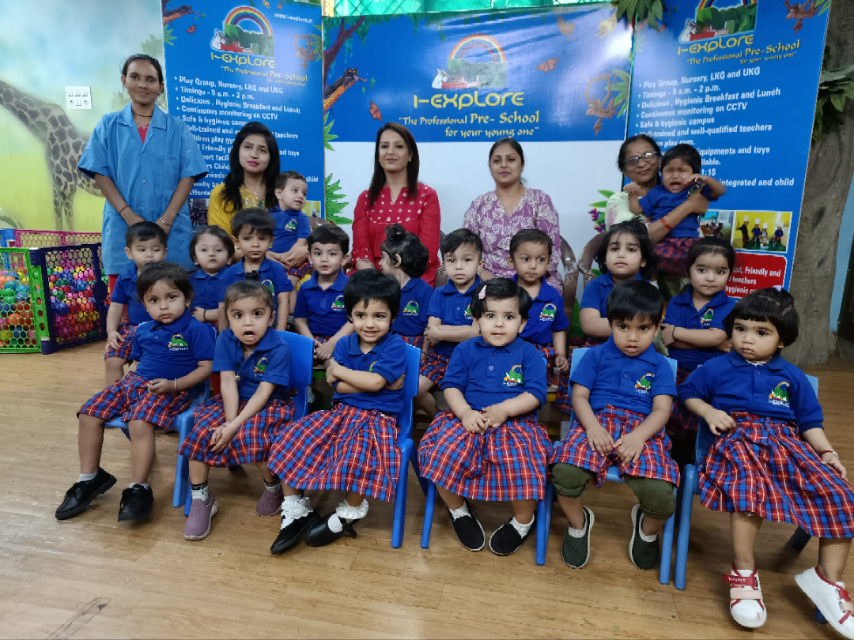

& Of course the most proudest moment  for me is parents trust & valuable feedback for my work is +  point for me .

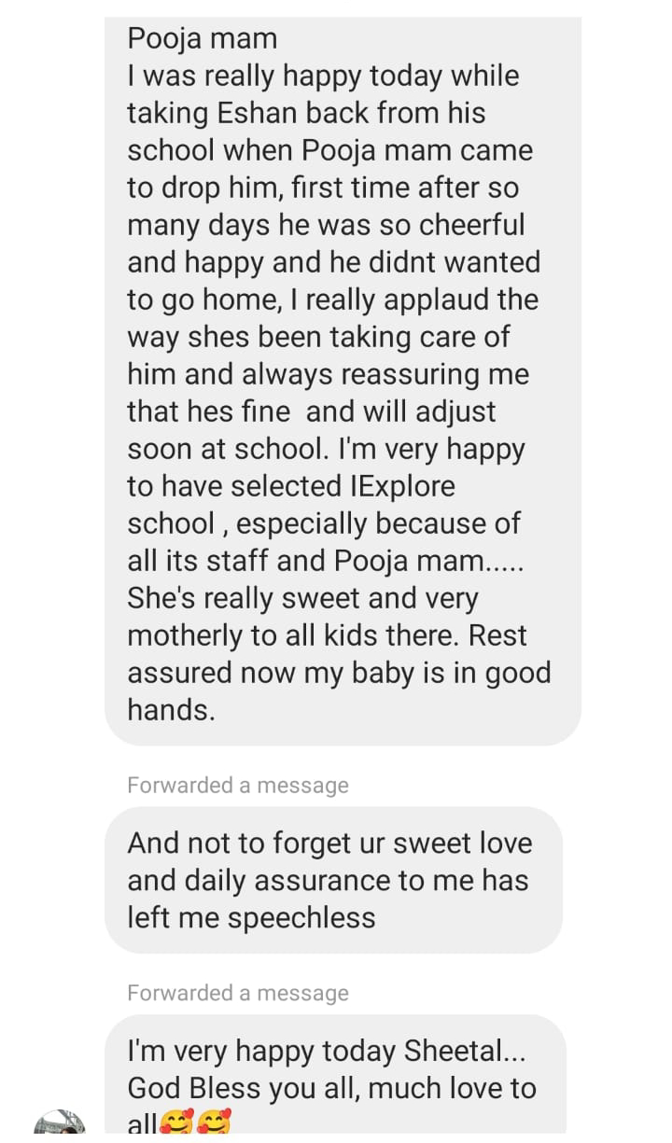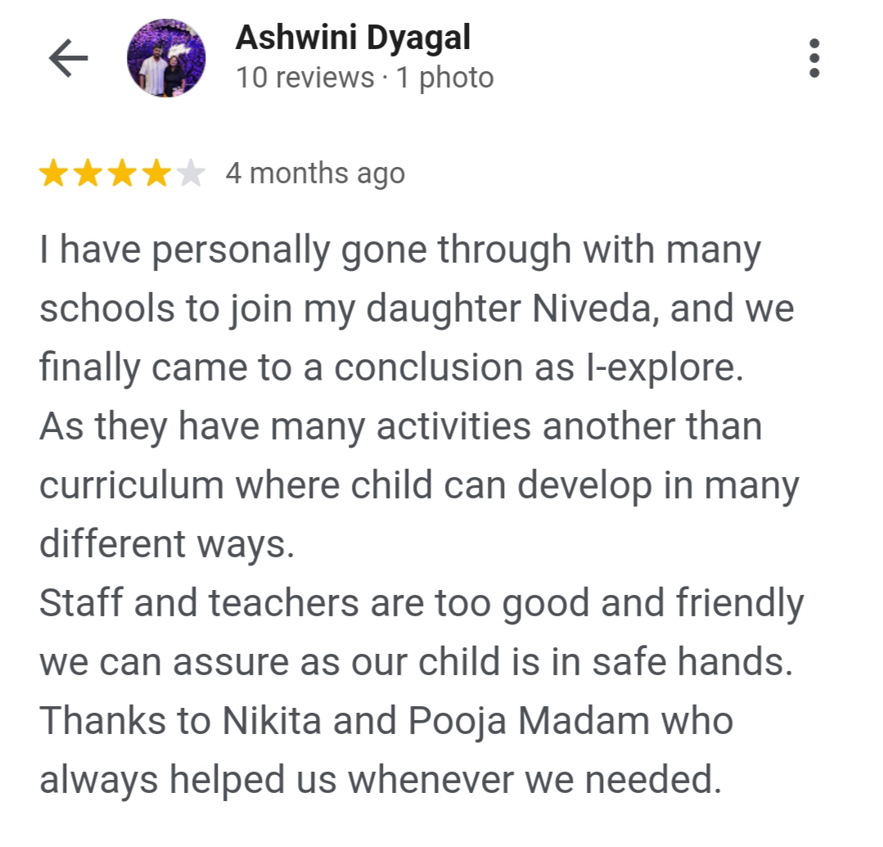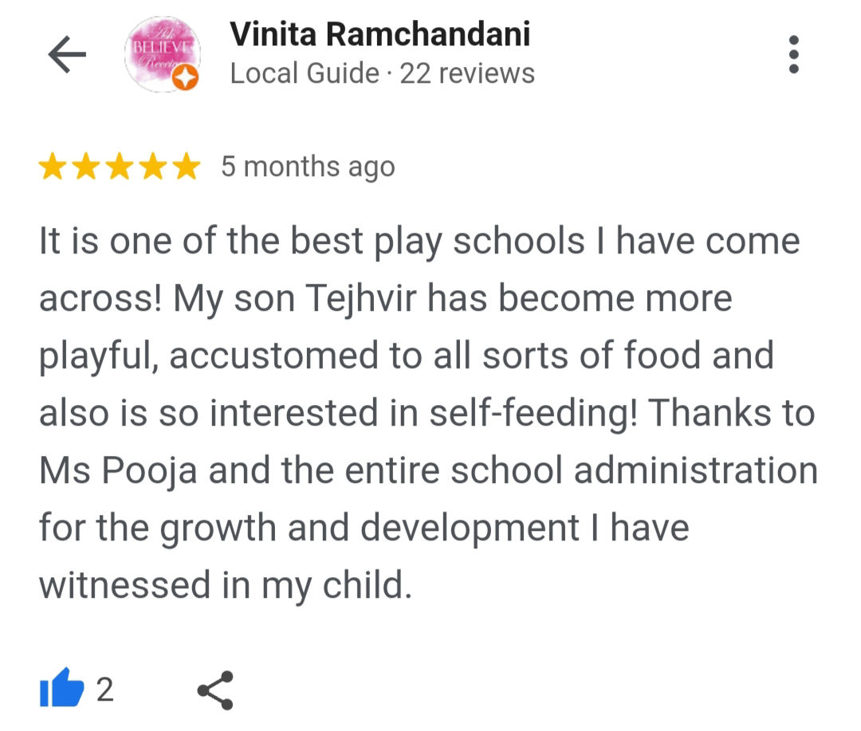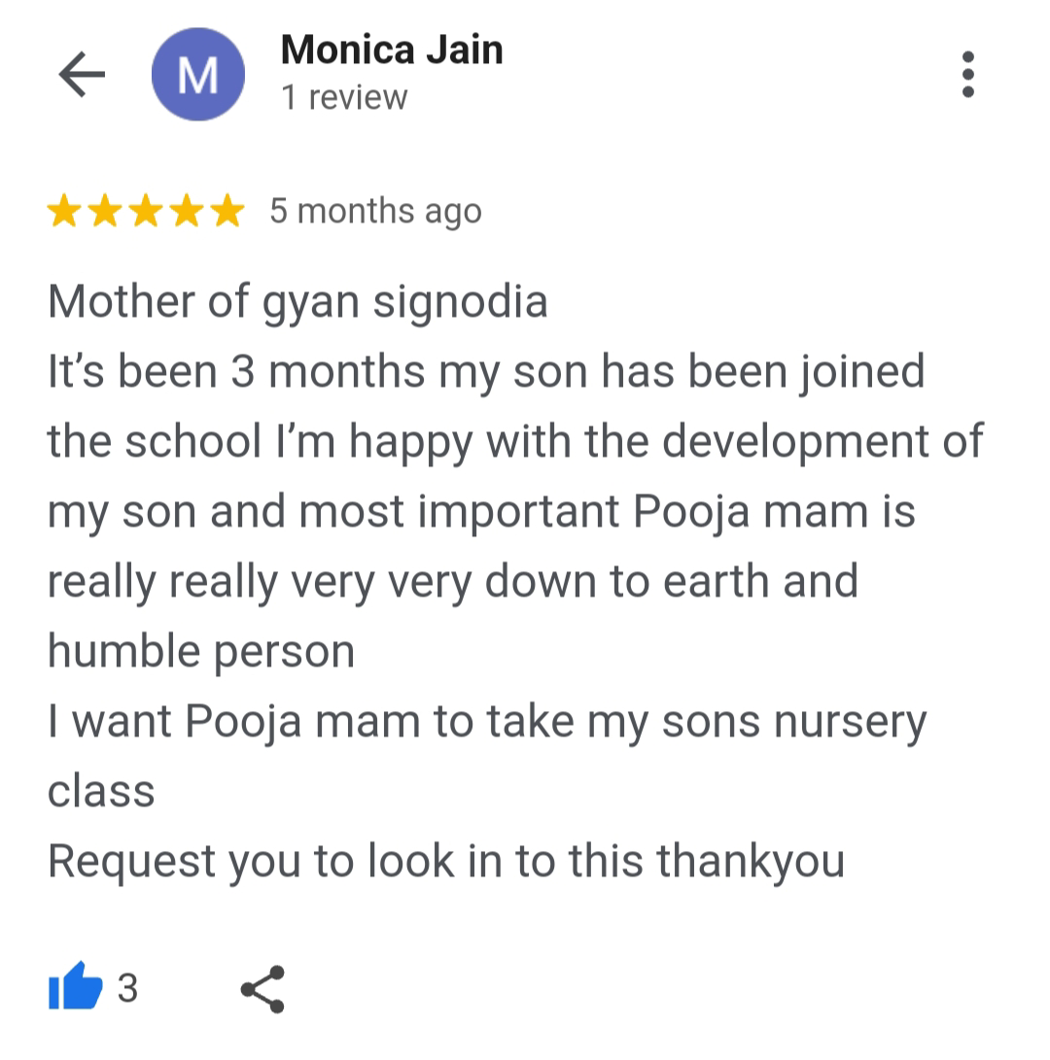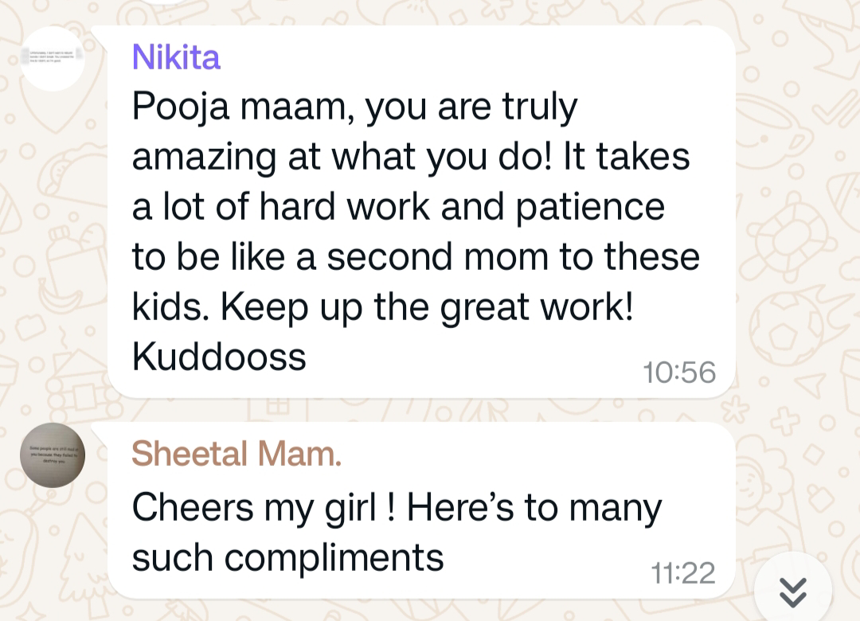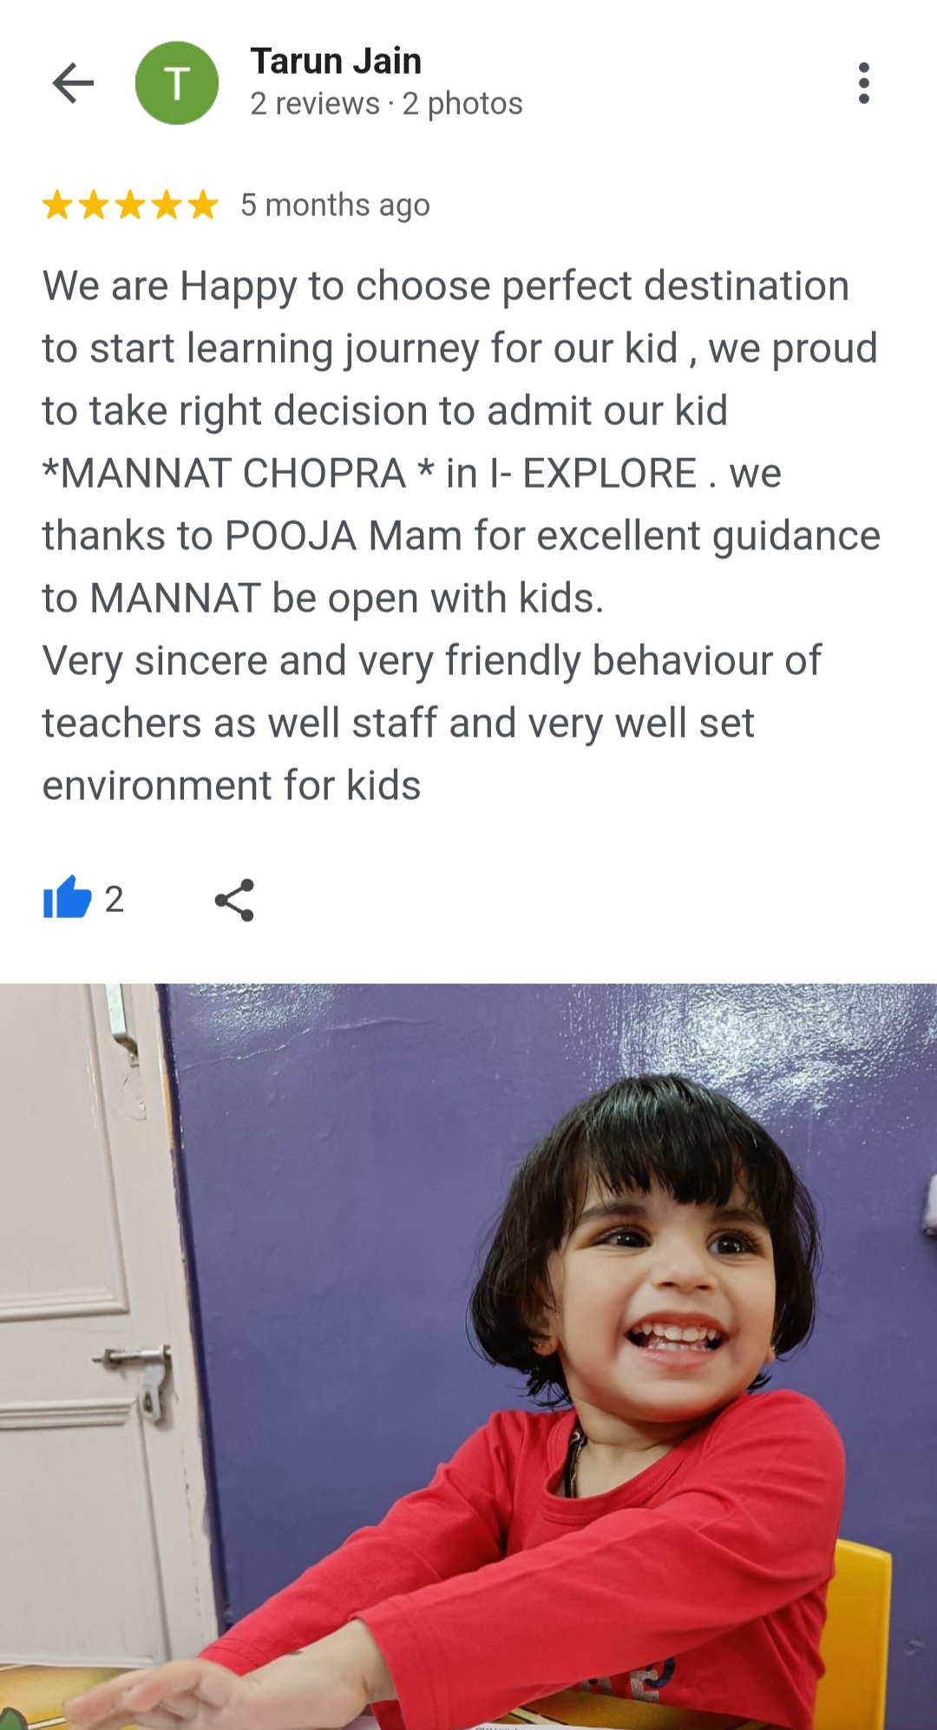

👉 Last but not the least  few kids got so attached to me  that they ask their parents to replace their new school teacher to Pooja ma'am. 🫣👉My heartfelt gratitude🙏 to the Director of I-Explore pre school Mrs.Sheetal Asrani ma'am for appointing me as a teacher which encouraged me to build my name (Pooja ma'am).

